**Topic:** Psoriasis on Eyelid in 2022 – Vigoursoul

**Focus keyword:** Psoriasis on Eyelid

**Meta Title:** Psoriasis on Eyelid in 2022 – Vigoursoul

**Meta Description**: Psoriasis on eyelids is an autoimmune skin condition that can be controlled with coping tactics, lifestyle changes, and medicines.

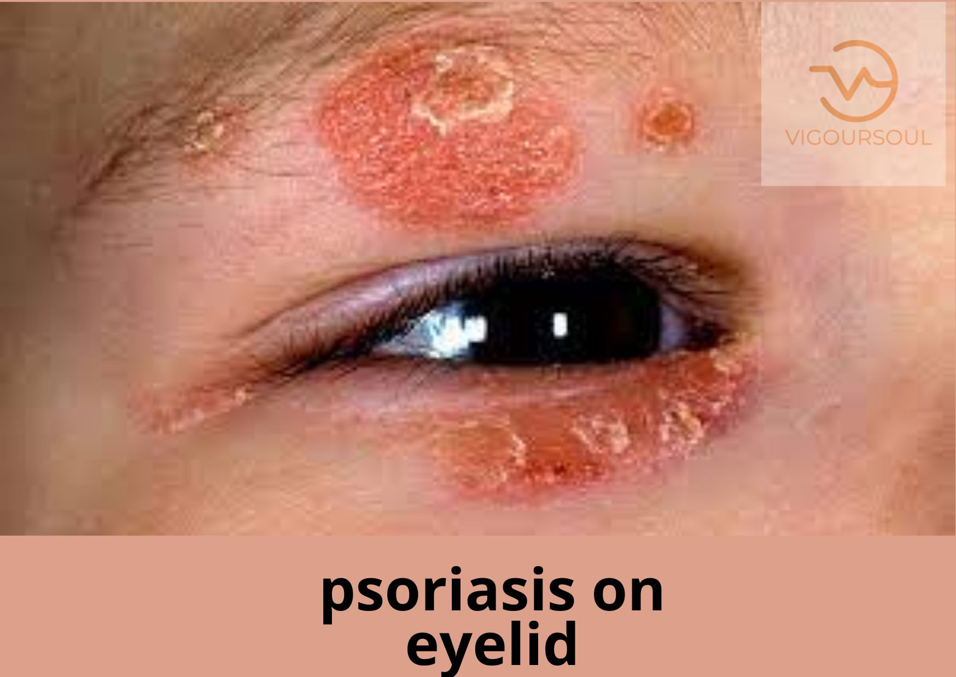

Eyelid psoriasis (pronounced "suh-RYE-uh-sis") is a non-contagious autoimmune skin condition that causes the body's skin cells to overproduce, resulting in inflammation and thick, scaly patches around the eye area that can irritate and swell the eyes.

**What is Psoriasis?**

* According to the National Psoriasis Foundation, psoriasis is an immune-mediated illness that affects more than 8 million people in the United States and 125 million worldwide (NPF). It manifests as reddish patches of skin with unpleasant silvery scales that burn and itch.
* When the immune system is out of balance, additional skin cells are produced at a greater rate than usual. This causes the skin to thicken and become scaly in particular regions (or to produce plaques). Skin cells regenerate once a month on average, but with psoriasis, this process occurs every three to four days.
* Psoriasis is most commonly found on the joints, scalp, elbows, and knees, although it can appear anywhere on the body, including the eyelids and around the eyes. Psoriasis affects men, women, and children, and while symptoms typically appear between the ages of 15 and 25, they can appear at any age.

**Psoriasis on the Eyelid:**

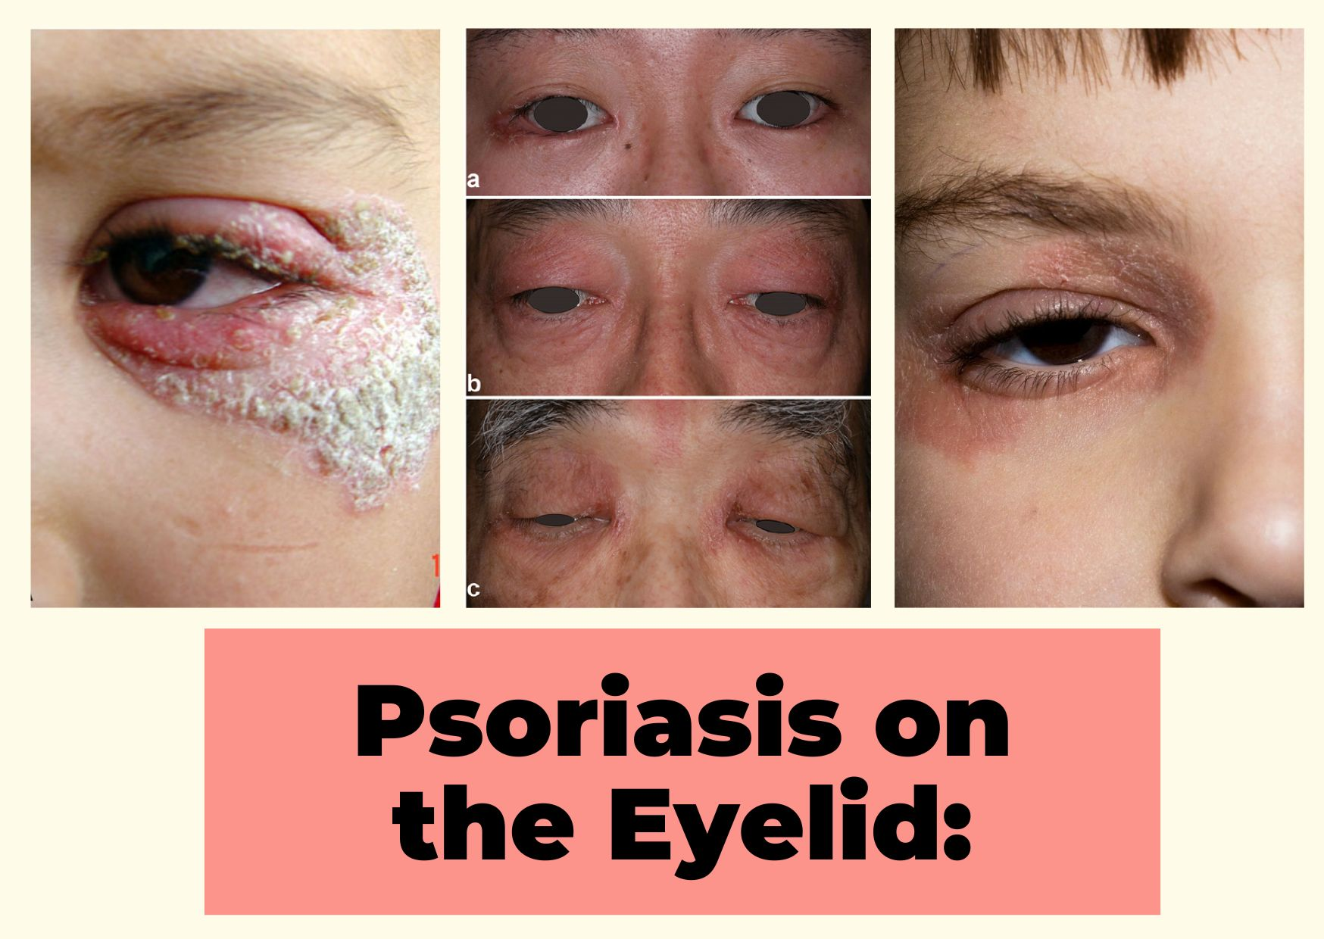

According to the National Psoriasis Foundation, 50% of persons with psoriasis have it on their face, generally at the hairline, brows, forehead, or between the nose and upper lip. Psoriasis around the eyes or on the eyelids, on the other hand, is extremely uncommon.

**Eczema Psoriasis on Eyelid:**

Emollients and moderate topical steroids prescribed by your doctor or other healthcare practitioner are used to treat eyelid eczema. Given the thinness of the eyelid skin, only modest topical steroids (0.5 - 1% hydrocortisone) are often suggested for eyelid eczema.

**Early stage Psoriasis on Eyelid:**

Psoriasis on or around the eyelids can be difficult to treat due to the sensitive skin in this area. Eyelid psoriasis symptoms include skin discoloration, scaling, and crusting around the eyelids. the rims of the eyes going upward or downward.

**Eyelid Psoriasis Symptoms:**

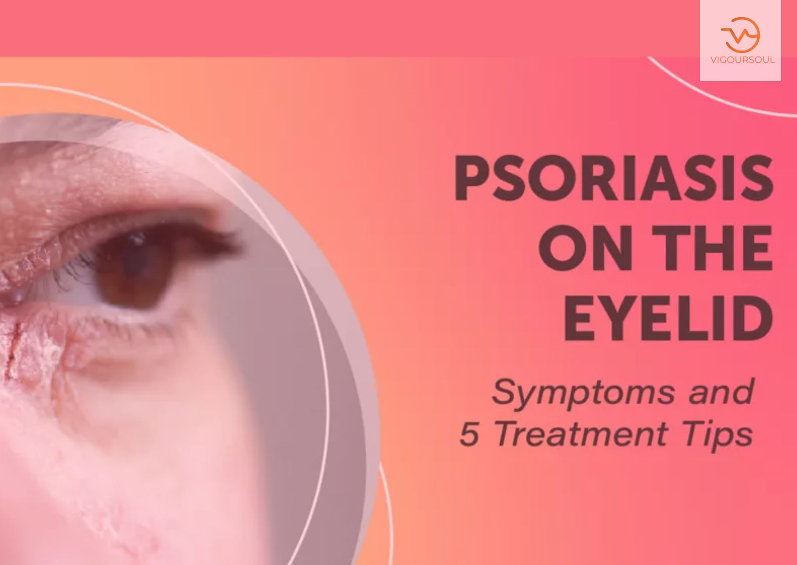

When psoriasis affects the eye area, it can cause dryness, irritation, discomfort, and possibly vision loss. When skin patches accumulate to a large enough size, it might cause difficulties opening and closing the eyes.

Other signs of eyelid psoriasis include:

* In the affected area, there are scaly, red growths.
* Skin that is dry and damaged and may bleed
* Inflammation of the eyelids that can cause eyelashes to rub against the eye (trichiasis)
* Scales that resemble dandruff and adhere to the eyelashes
* Scales forcing the eyelid outward cause eye dryness.
* Eyelid pain when moving, opening, or closing.

**Eyelid Psoriasis Causes:**

Psoriasis is generally thought to be an immune system illness, but genetics can also play a role (though there may be no family history of the disease). Furthermore, some triggers, such as: might cause symptoms to flare up or worsen.

* Stress
* Illness, particularly throat infections (e.g., strep throat), as well as immunological disorders
* Bug bites, sunburns, and some immunizations cause skin damage.
* Weather conditions such as less sunlight and lower humidity might result in drier warm air indoors.
* Allergies, smoking, excessive alcohol consumption, particular foods, and/or environmental variables
* Medications like beta blockers, which are used to reduce excessive blood pressure or heart rate, or lithium, which is used to treat bipolar illness.

**Eyelid Psoriasis Treatment:**

When developing a treatment plan for eyelid psoriasis, it is critical to consult with a dermatologist and an eye specialist, as disorders that affect the sensitive areas on the face and around the eyes must be handled with care.

The following methods can be used to treat eyelid psoriasis:

* Retinoid, corticosteroids, and calcineurin inhibitors are examples of topical steroids that can help reduce inflammation and slow excessive skin cell multiplication.
* To reduce psoriasis plaques, non-steroid topical such as enthralling, synthetic vitamin D3, and vitamin A can be utilized.
* Over-the-counter topical can provide relief and aid in the removal of itchy scales. Salicylic acid, coal tar, bath solutions, shampoos, lotions, aloe Vera, and jojoba are all options.
* Damp dressings, for example, might relieve itching by covering the affected area with a wet bandage.
* Phototherapy (light therapy) uses a particular machine that produces ultraviolet light onto the skin to assist relieve itching and inflammation.
* Lesions around the eyes can be cleared with oral drugs such as secukinumab (Cosentyx) or apremilast (Otezla).

**Treatment options include**:

**Topical therapy:**

A doctor may prescribe corticosteroid ointment or another substance.

To treat psoriasis around the eyes, doctors may prescribe specially formulated steroid ointments in rare circumstances.

Because the skin of the eyelids is prone to harm, and difficulties can emerge with long-term use, a doctor must monitor the careful application of the ointment. A person may need to see an ophthalmologist on a frequent basis to check for glaucoma or cataracts.

For psoriasis, doctors may also give tacrolimus or Protopic ointments. These drugs typically treat atopic dermatitis, sometimes known as eczema, but they can also assist with psoriasis inflammation and dryness.

**Systemic medications:**

A doctor may give a systemic oral or injectable drug depending on how severely the psoriasis affects the eyelids and how well the area responds to prior treatments.

These are some examples:

* retinoid taken orally, such as citrating,
* methotrexate,
* and cyclosporine

These medications can have negative side effects. Doctors typically prescribe them for short-term usage to treat a flare, which is when symptoms escalate.

**Biologic therapy:**

This is a new type of medicine that targets specific immune system components. It appears to help lessen the amount of flares and their severity.

When choosing whether to prescribe a biologic medicine, a doctor will examine the type of psoriasis and the severity of symptoms.

When symptoms are moderate to severe, current recommendations indicate using a biologic medication.

**Tips for living with eyelid psoriasis**

Some regular behaviors and activities can aggravate eyelid psoriasis symptoms. We will cover how to continue these activities while avoiding the development of psoriasis symptoms on the eyelids in the sections following.

**Makeup:**

* Cosmetics can help to conceal skin discoloration and scales, but persons with psoriasis should use makeup designed for sensitive skin.
* Makeup can also interact with a person's topical treatments and irritate the eyelid.
* People with psoriasis should consult a doctor or dermatologist about the best ways to manage eyelid psoriasis with makeup.

**Eyebrow piercings:**

Eyebrow piercings may raise the chance of a flare near the eye for persons with psoriasis, as piercing, tattoos, and other types of skin damage can trigger symptoms.

**Contact lenses:**

Wearing contact lenses should be safe as long as a person administers their topical medication correctly and it does not get into their eyes.

A person may discover that a specific brand of contact lens or solution produces greater irritation, but there should be no further concerns.

**FAQS**

**Can Eyelid Psoriasis be Cured?**

It is not curable, although it can be treated. Psoriasis develops when your body's skin cells multiply too quickly due to rapid cell synthesis. Excess production results in thick, scaly spots on your body. This can include the sensitive skin around your eyes in rare cases.

**Can you put Psoriasis Cream on your Eyelid?**

Tacrolimus (Proteomic) (Proteomic). This prescription ointment, also known as a topical calcineurin inhibitor, is frequently used to treat eczema, another prevalent skin ailment. However, tacrolimus may also be used to treat other skin irritations such as psoriasis. It is safe to use near your eyes.

**How do I get rid of Eyelid Crust?**

Mix warm water with a gentle cleanser, like baby shampoo. Dip a clean, soft cloth or cotton swab in the warm cleanser and water mixture. Press the cloth against your closed eye for a few minutes to loosen crusts. This can also help keep your oil glands from clogging.

**Why are my Eyelids Crusty?**

Seborrhea blepharitis – The most common type, this is not a real infection but is caused by incorrect function of the eyelid oil glands. This results in the formation of greasy, waxy scales around the eyelid borders. Seborrhea may be part of a larger skin condition that affects other places as well.

**What Cream is good for Eyelid Dermatitis?**

Crave Hydrating Facial Cleanser and Vichy Mineral 89 Hyaluronic Acid Face Moisturizer is two of our favorite products. He also recommends hydrating the skin on the eyelids using petroleum-based products like Vaseline or Aquaporin to help rebuild the skin barrier.

**Conclusion:**

Psoriasis can be a difficult condition to manage, especially if it affects the eyelids. This is due to the extremely sensitive skin around this location.

Anyone who discovers new symptoms or is concerned about current symptoms should consult a doctor, as there are numerous treatment choices.